8 BIT ADVANCED RISC PROCESSOR
A Project Based Learning Report Submitted in partial fulfilment of the requirements for the award of the degree

of

Bachelor of Technology
in The Department of Electronics and Communication Engineering
23VLS3303A and VLSI PHYSICAL DESIGN AUTOMATION
23SDEC18A and VLSI SUBMICRON DESIGN AND VERIFICATION
23VLS3202R and TESTING AND VERIFICATION OF VLSI CIRCUITS

Submitted by
2310040049: Vijaya Navya Sri
2310049143: Srija Hitheshna

Under the guidance of
Dr. Kasi Bandla, Dr. Kayam SaiKumar & Dr. N. Phalguni Singh


Department of Electronics and Communication Engineering
Koneru Lakshmaiah Education Foundation, Aziz Nagar
Aziz Nagar – 500075
JAN - 2025.

INTRODUCTION

8-Bit RISC Processor Project
An 8-bit RISC (Reduced Instruction Set Computer) processor project provides a solid introduction to computer architecture and digital design principles. The processor works with 8-bit data words, which means it processes information in chunks of 8 bits at a time. This allows it to handle values from 0 to 255 in unsigned representation. The "RISC" philosophy focuses on simplicity and efficiency with a streamlined instruction set, where most operations finish in a single clock cycle. This makes the design more predictable and easier to pipeline compared to complex instruction set computers (CISC). This architecture offers a good balance between educational value and practical implementation complexity.
The processor's internal architecture includes several interconnected components that work together. At its core are general-purpose registers, usually between 8 and 16, that provide fast temporary storage for actively processed data. This reduces the need for frequent memory access. The Arithmetic Logic Unit (ALU) carries out all computational tasks, including arithmetic functions like addition and subtraction, logical operations such as AND, OR, and XOR, as well as bit shifting and comparison operations. Special-purpose registers include the Program Counter (PC), which tracks the address of the next instruction to execute, the Stack Pointer (SP) for managing subroutine calls and local data, and a Status Register that contains flags indicating conditions like zero results, arithmetic overflow, carry bits, and negative values.
The instruction set architecture outlines how the processor talks to programmers and links hardware with software. A typical 8-bit RISC processor may feature 32 to 64 distinct instructions organized into logical groups: data movement instructions for transferring values between registers and memory, arithmetic and logical operations for computation, control flow instructions for implementing branches and loops, and stack operations for function calls and returns. The instruction encoding needs careful design to fit operation codes, addressing modes, and operand specifications within limited bit patterns. It often uses fixed-length instruction formats that simplify decoding logic and support the goal of single-cycle execution.
Memory organization in an 8-bit RISC system usually uses a 16-bit address bus. This allows access to 64KB of addressable space divided between program memory (ROM) and data memory (RAM). The memory interface includes address decoding logic, read/write control signals, and timing circuits that sync memory operations with the processor clock. Addressing modes can include immediate (constant values), direct (absolute memory addresses), indirect (addresses stored in registers), and indexed addressing for array access. The interaction between the processor and memory subsystem greatly affects overall system performance and must be optimized to minimize wait states and maximize throughput.
Implementing an 8-bit RISC processor can take different forms based on your goals and resources. Hardware description languages like Verilog or VHDL let you design and simulate the processor in software before synthesizing it onto an FPGA for real hardware testing. This offers quick prototyping and debugging capabilities. Alternatively, building the processor from discrete logic chips gives hands-on experience with actual digital components and signal timing issues, though this method is more time-consuming and complex. Software-based emulation in languages like C, Python, or Java provides an excellent platform for developing and testing the instruction set and assembler without hardware costs. This makes it especially useful for algorithm development and compiler testing. Each implementation approach presents unique learning opportunities along with trade-offs between complexity, cost, and educational value.

LITERATURE SURVEY

- Historical Context and Foundational Work
The RISC architecture philosophy emerged in the early 1980s through pioneering research at UC Berkeley and Stanford University. David Patterson's Berkeley RISC project and John Hennessy's MIPS project at Stanford fundamentally challenged the prevailing CISC design paradigm by demonstrating that simpler instruction sets could achieve higher performance through efficient pipelining and faster clock rates. Their seminal work "Computer Architecture: A Quantitative Approach" established key RISC principles: a small, orthogonal instruction set, load-store architecture with operations only between registers, simple addressing modes, and fixed-length instruction formats. These foundational concepts directly influenced commercial processors like ARM, MIPS, and SPARC, proving that complexity should reside in software rather than hardware.
- Contemporary 8-Bit RISC Implementations
Modern literature on 8-bit RISC processors focuses primarily on educational implementations and embedded system applications. Researchers have published numerous FPGA-based designs that demonstrate RISC principles at a manageable scale. Notable implementations include single-cycle and pipelined variants using Verilog and VHDL, often targeting Xilinx or Altera FPGA platforms. Studies by Kumar et al. and Patel et al. have explored various optimization techniques including instruction set minimization, register file organization, and control unit design strategies. The literature emphasizes trade-offs between hardware complexity, instruction density, and execution speed, with many implementations achieving clock frequencies between 50-100 MHz on modern FPGAs while maintaining low resource utilization.
- Instruction Set Architecture Research
Research on 8-bit RISC instruction sets reveals convergence toward certain optimal configurations. Most successful designs implement 16 to 32 core instructions covering data movement, arithmetic/logical operations, branching, and stack manipulation. Studies have analyzed instruction encoding schemes, with most 8-bit processors using either 8-bit or 16-bit instruction words depending on addressing requirements. Work by Singh and Chowdhury demonstrates that carefully chosen instruction sets can achieve good code density despite RISC's typically lower instruction density compared to CISC. Research also addresses addressing mode selection, with most 8-bit RISC designs supporting 3-5 modes: immediate, register direct, register indirect, and indexed addressing, balancing flexibility against decoding complexity.
- Hardware Implementation Methodologies
The literature presents diverse implementation approaches for 8-bit RISC processors. Hardware description language (HDL) based designs dominate academic research, with comparative studies evaluating Verilog versus VHDL for processor design in terms of simulation speed, synthesis results, and design productivity. FPGA implementation studies focus on resource optimization, timing analysis, and power consumption, with research showing that 8-bit RISC processors typically consume 500-2000 logic elements on modern FPGAs. Some researchers have explored asynchronous design techniques for low-power applications, while others investigate multi-cycle and pipelined implementations to improve throughput. Recent work has also examined soft-core processors as alternatives to commercial IP cores, emphasizing customizability and educational value.
- Design Verification and Testing
Literature on processor verification emphasizes systematic testing methodologies essential for ensuring correct operation. Researchers employ simulation-based verification using comprehensive test benches that validate each instruction individually and in combination. Formal verification techniques using model checking and theorem proving have been applied to small processor designs to mathematically prove correctness properties. Studies discuss test program development strategies, including directed tests for specific instructions and random instruction sequence generation for coverage analysis. Performance evaluation metrics discussed in literature include instructions per cycle (IPC), clock frequency, code size efficiency, and hardware resource utilization, providing standardized benchmarks for comparing different implementations.
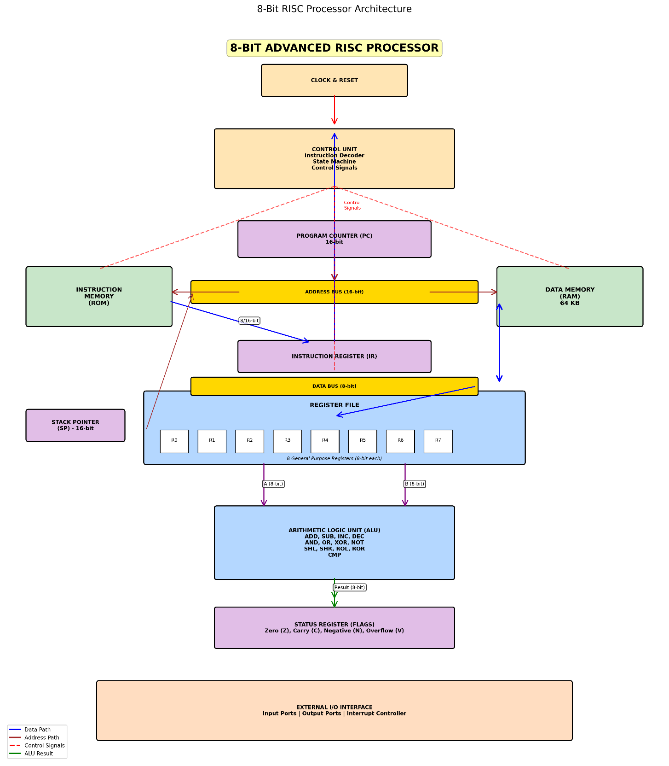

- Applications and Future Directions
Current research explores applications of 8-bit RISC processors in embedded systems, IoT devices, and educational platforms. Studies demonstrate their suitability for control applications, sensor interfacing, and simple data processing tasks where low power consumption and cost are priorities. Educational literature emphasizes these processors as teaching tools for computer architecture courses, providing students hands-on experience with complete system design. Emerging research directions include integration with peripheral controllers, exploration of custom instruction set extensions for specific applications, and investigation of security features like instruction encryption and secure boot mechanisms. The literature suggests continued relevance of 8-bit RISC processors in resource-constrained environments and educational contexts despite the dominance of 32-bit and 64-bit processors in mainstream computing.

REFERENCES

[1] D. A. Patterson and J. L. Hennessy, Computer Organization and Design: The Hardware/Software Interface, 5th ed. Burlington, MA, USA: Morgan Kaufmann, 2014.

[2] J. L. Hennessy and D. A. Patterson, Computer Architecture: A Quantitative Approach, 6th ed. Cambridge, MA, USA: Morgan Kaufmann, 2019.

[3] M. M. Mano and M. D. Ciletti, Digital Design, 5th ed. Upper Saddle River, NJ, USA: Pearson, 2013.

[4] D. M. Harris and S. L. Harris, Digital Design and Computer Architecture, 2nd ed. Waltham, MA, USA: Morgan Kaufmann, 2012.

[5] C. H. Roth Jr. and L. L. Kinney, Fundamentals of Logic Design, 7th ed. Boston, MA, USA: Cengage Learning, 2014.

[6] S. Palnitkar, Verilog HDL: A Guide to Digital Design and Synthesis, 2nd ed. Upper Saddle River, NJ, USA: Prentice Hall, 2003.

[7] IEEE Standard for Verilog Hardware Description Language, IEEE Std 1364-2005, 2006.

[8] IEEE Standard for SystemVerilog—Unified Hardware Design, Specification, and Verification Language, IEEE Std 1800-2017, 2018.

[9] J. Bhasker, A Verilog HDL Primer, 3rd ed. Star Galaxy Publishing, 2003.

[10] Xilinx Inc., Vivado Design Suite User Guide, San Jose, CA, USA, 2020.

